Data Visualization: Patterns of AIDS deaths

Mohajit Banik

Data Analysis with Python

National Institute of Industrial Training

Ishapore, West Bengal

mohajit25@gmail.comArpita Goswami

Data Analysis with Python

National Institute of Industrial Training

Barrackpore, West Bengal

goswamiarpita872@gmail.com

*Abstract*— This master report synthesizes findings from five comprehensive studies that analyze distinct medical datasets, each aimed at enhancing healthcare delivery and operational efficiency. These studies span a wide range of healthcare topics, including hospital operations, pregnancy outcomes, mental health impacts, and AIDS-related mortality. By examining these diverse datasets, the report highlights the critical role of data-driven decision-making in improving various aspects of healthcare. This holistic approach provides a more comprehensive understanding of healthcare trends, ultimately enabling more informed decisions and more effective healthcare strategies across different domains.

The first study focuses on hospital data from December 19, 2019, examining patient demographics, disease prevalence, resource utilization, and operational efficiency. By identifying trends and patterns, this study aims to optimize hospital operations and improve patient care. The results emphasize the critical role of leveraging historical and recent data to inform operational decisions and enhance overall hospital management. Such data-driven insights are crucial for streamlining resources, improving patient outcomes, and enhancing the effectiveness of healthcare delivery systems.

The second study analyzes pregnancy demographics from 1977 to 2005, focusing on trends and disparities in pregnancy outcomes across various demographic groups. This study explores variables such as age, ethnicity, and socioeconomic status to identify significant variations in pregnancy outcomes. The findings reveal notable disparities, highlighting the impact of these factors on maternal and neonatal health. This underscores the need for tailored healthcare strategies that address specific demographic challenges and work towards reducing disparities in pregnancy outcomes. By understanding these variations, healthcare providers can develop more targeted interventions to improve maternal and neonatal health outcomes, ultimately leading to better overall public health.

The third study investigates the mental health impacts of COVID-19 quarantine measures, exploring how quarantine affects mental well-being across different demographic groups. By analyzing mental health indicators and quarantine-related factors, this study reveals that age, socioeconomic status, and pre-existing mental health conditions play significant roles in determining mental health outcomes during quarantine. The findings emphasize the importance of targeted mental health interventions, particularly for vulnerable groups affected by quarantine measures. Understanding these impacts helps in designing more effective mental health support systems and resources, addressing the unique needs of individuals experiencing heightened stress and anxiety due to prolonged isolation.

The fourth study focuses on mental health trends among tech professionals, examining the influence of job roles, work environments, and access to mental health resources on mental health outcomes. The analysis highlights that high-pressure job roles and inadequate mental health resources contribute to increased levels of anxiety and depression within the tech industry. The findings stress the need for comprehensive support systems tailored to the unique challenges faced by tech professionals. By improving access to mental health resources and implementing supportive work environments, employers can mitigate the adverse effects on mental health and foster a healthier, more productive workforce in the tech sector.

The final study reviews trends in AIDS-related deaths from 2000 to 2014, identifying significant factors influencing mortality rates. The analysis considers variables such as age, state of residence, and healthcare access, revealing that states with better healthcare infrastructure and higher awareness experience lower AIDS mortality rates. This underscores the importance of targeted public health interventions and the need for comprehensive healthcare support systems to address AIDS-related challenges effectively. Enhancing healthcare infrastructure and increasing awareness can lead to significant improvements in reducing AIDS-related deaths, ultimately contributing to better public health outcomes and more effective management of the AIDS epidemic.

In conclusion, this master report integrates diverse datasets to provide a comprehensive view of healthcare trends and challenges. The consolidated insights offer valuable recommendations for improving healthcare strategies, optimizing resource allocation, and addressing specific health issues across various domains. By leveraging data-driven approaches, healthcare systems can enhance their operational efficiency, develop targeted interventions, and ultimately improve overall public health outcomes. The findings from these studies collectively highlight the importance of a strategic, data-informed approach to healthcare, paving the way for more effective solutions to pressing health challenges.

Introduction

The healthcare sector increasingly leverages data-driven insights to enhance patient care and operational efficiency. This Master Report consolidates detailed analyses of five diverse medical datasets, each providing unique perspectives on significant health challenges and trends. By integrating findings from various domains, we aim to demonstrate the breadth and depth of data analytics' impact on healthcare, offering a comprehensive overview of how different facets of medical data can drive better outcomes. Our goal is to showcase how meticulous data analysis can uncover valuable patterns and correlations, ultimately informing better decision-making, optimizing resource utilization, and improving overall healthcare delivery. Through this report, we highlight the transformative potential of data analytics in addressing critical issues in the healthcare industry and advancing patient care.

Firstly, we examined a comprehensive dataset of hospital data collected on December 19, 2019. This dataset encompasses a wide range of information, including patient demographics, medical records, treatment details, and hospital operations. By analyzing this data, we aimed to uncover patterns and trends that could inform better decision-making and improve healthcare outcomes. Our exploration included various aspects such as disease prevalence, treatment outcomes, resource utilization, and operational efficiency. By understanding these elements, we sought to provide valuable insights into the hospital’s performance and highlight areas for improvement. This study underscores the importance of leveraging historical data to drive future strategies and optimize healthcare delivery.

Secondly, we delved into a dataset of pregnancy demographics collected from 1977 to 2005, focusing on factors influencing maternal and neonatal health outcomes. This dataset includes a wide range of demographic variables such as age, ethnicity, socioeconomic status, and health indicators of pregnant individuals. By examining these variables, we aimed to identify significant trends, patterns, and disparities that could inform healthcare policies and practices to enhance maternal and neonatal health. Demographic characteristics like age, ethnicity, and socioeconomic status play a pivotal role in determining pregnancy outcomes. For instance, younger and older age groups often face higher risks of complications, while individuals from lower socioeconomic backgrounds may encounter challenges in accessing quality prenatal care. Additionally, ethnic disparities in birth outcomes highlight the need for targeted interventions to address the specific needs of diverse populations.

Thirdly, we analyzed a dataset of mental health indicators during the COVID-19 quarantine, examining the impact of quarantine measures on mental health. This dataset includes demographic variables, mental health metrics, and quarantine-related factors, providing a holistic view of the pandemic’s impact. Quarantine has disrupted routines, social interactions, and economic stability, leading to increased stress, anxiety, and depression. Key factors such as age, socioeconomic status, and pre-existing mental health conditions influence these outcomes, with younger individuals and those from lower socioeconomic backgrounds being especially vulnerable. By leveraging advanced data analysis techniques, we aimed to identify significant correlations and insights that could inform mental health interventions and policies.

Fourthly, we explored mental health trends among tech professionals in the post-pandemic era, focusing on the challenges introduced by remote and hybrid work environments. This dataset provides a comprehensive overview of mental health trends among tech professionals, including demographic information, job roles, work environments, mental health conditions, and access to mental health resources. The tech industry is known for its high-pressure environment, long working hours, and constant need for innovation, all of which can contribute to mental health issues such as anxiety, depression, and burnout. By analyzing these variables, we aimed to uncover patterns and correlations that could inform better mental health support strategies within the tech industry. Our analysis leverages advanced data processing techniques, including data cleaning, exploratory data analysis (EDA), and machine learning algorithms, to ensure robust and insightful findings.

Finally, we analyzed a dataset of AIDS-related deaths from 2000 to 2014, highlighting the ongoing efforts and challenges in combating the AIDS epidemic. This dataset provides a comprehensive overview of AIDS-related deaths across various states, capturing the latest trends and patterns in AIDS mortality. It encompasses a wide range of variables, including demographic information, state-wise distribution, age groups, and the timeline of deaths. By examining these variables, we aimed to uncover patterns that could inform public health strategies and interventions to reduce AIDS-related mortality. Despite advancements in medical treatments and preventive measures, AIDS remains a critical issue. Understanding the prevalence and factors associated with AIDS-related deaths is crucial for developing effective interventions and policies.

Through these comprehensive analyses, this Master Report underscores the transformative potential of data analytics in addressing diverse healthcare challenges. By meticulously cleaning, processing, and analyzing various medical datasets, we provide actionable insights that can inform healthcare strategies and policies. Ultimately, this report demonstrates the vital role of data analytics in improving patient care, optimizing healthcare delivery, and addressing public health challenges, contributing to more effective and efficient healthcare systems.

## **Data Cleaning**

Data cleaning is a pivotal step in data preprocessing, essential for transforming raw data into a polished, analysis-ready dataset. It is a critical phase in data preparation that involves identifying and correcting inaccuracies, inconsistencies, and errors in a dataset to ensure that it is accurate, complete, and reliable for analysis. This process enhances data quality by addressing issues such as missing values, incorrect data types, and formatting errors. Effective data cleaning lays the foundation for meaningful insights and accurate decision-making.

In the 5 Analysis reports, we have done several cleaning works. Some of them are:

1. **Drop Columns:**

Dropping columns entails removing specific columns from the dataset that are deemed unnecessary or irrelevant for the analysis. This step is essential for reducing data complexity and focusing only on relevant variables. For example, in a medical dataset, columns with excessive or irrelevant details, such as "Patient Notes" when they are not needed for statistical analysis, are dropped. This simplification helps to enhance the efficiency of the data processing and analysis by reducing the dimensionality of the dataset.

1. **Drop Rows:**

Dropping rows involves removing individual rows from the dataset that contain incomplete, irrelevant, or erroneous data. This step is crucial for maintaining the integrity of the analysis. For instance, if certain rows have missing key attributes like "Diagnosis" or contain outlier values that cannot be justified, these rows are removed. By eliminating such rows, the dataset becomes cleaner and more accurate, which helps in deriving valid conclusions from the analysis.

1. **Remove, Replace, or Drop Null Values:**

Null values signify missing or undefined data points in a dataset. Addressing null values is vital for maintaining data consistency and quality:

- **Remove**: Columns or rows with a high proportion of null values can be removed if they lack significant information. For example, if a column with demographic details has too many missing entries, it may be dropped to avoid skewing the analysis.

-**Replace**: Null values can be substituted with appropriate values such as mean, median, or a predefined constant. For example, replacing missing values in a "Blood Pressure" column with the median value ensures that the dataset remains complete and the analysis remains robust.

- **Drop**: When the proportion of missing values is minimal and does not significantly impact the dataset, rows with null values can be dropped. This approach is useful when the missing data is sparse and does not bias the overall results.

1. **Remove Commas**

Commas in numerical fields can impede data processing as they are often used as thousands of separators in text format. Removing commas from numeric fields ensures that the data is in a standard numerical format, which facilitates accurate calculations and analysis. For instance, converting "1,234" to "1234" allows for correct summation and statistical operations.

1. **Change Data Types:**

Converting data types is necessary to ensure that each data field is in the appropriate format for analysis:

- **String to Integer**: Textual representations of numbers need to be converted to numeric data types to enable mathematical operations. For example, converting "42" (a string) to 42 (an integer) allows for proper arithmetic operations and aggregations.

- **Integer to String**: Conversely, numeric data may be converted to strings when they represent categorical variables or identifiers rather than quantities. For example, converting a patient ID number from integer to string format ensures it is treated as an identifier rather than a numeric value.

1. **Sort a Column:**

Sorting a column organizes the data in a meaningful order, which can be crucial for identifying trends, patterns, and outliers. Sorting can be performed in ascending or descending order based on the analysis requirements. For instance, sorting patient ages in ascending order can help in visualizing age distribution and detecting any anomalies or trends.

1. **Rename Columns:**

Renaming columns involves changing the names of columns to more descriptive and relevant labels. This improves the clarity and readability of the dataset, making it easier for analysts and stakeholders to understand the data. For example, renaming a column from "Col1" to "Patient Age" provides immediate context and helps in interpreting the data more effectively.

**Conclusion**:

After completing the data cleaning process, the dataset has been meticulously refined to address inaccuracies, inconsistencies, and irrelevant information. This involved dropping unnecessary columns and rows, removing or replacing null values, eliminating commas, changing data types, sorting columns, and renaming columns for clarity. By carefully executing these steps, we have ensured the dataset's accuracy, reliability, and relevance. The cleaned dataset, now robust and well-organized, is ready to be forwarded to the visualization phase, where it will be transformed into visual representations such as charts, graphs, and dashboards. This stage will facilitate the extraction of insights and support informed decision-making based on the cleaned and organized data. By converting raw data into compelling visuals, we can communicate complex information effectively, uncover hidden patterns, and enable stakeholders to make data-driven decisions with confidence.

## **Data Visualizations**

Data visualization is essential for transforming cleaned and processed datasets into visual formats like charts, graphs, maps, and dashboards. It simplifies complex data, making patterns, trends, and correlations easily identifiable. By leveraging visual elements, it enhances understanding and communication, enabling stakeholders to make data-driven decisions. Effective data visualization emphasizes clarity, accuracy, and relevance, ensuring that visual representations correctly reflect the data and convey meaningful insights. In healthcare, visualizations can depict patient demographics, disease prevalence, and treatment outcomes, highlighting key findings and informing better decision-making in a concise and accessible manner.

* **Visualization: Hospital data on December 19, 2019**
* Line Plot of Drug Frequency by Gender:

The first visualization is a line plot that examines the frequency of drug use by different genders. In this plot, the x-axis represents the frequency of drug use, while the y-axis lists the names of various drugs. Different lines are used to differentiate between genders, providing a comparative view of how frequently each drug is used by males and females. This visualization is useful for identifying trends and patterns in drug usage across genders, helping to reveal if certain drugs are more commonly used by one gender over another.

* Line Plot of Dosage by Drug Name:

The second visualization is another line plot, but this one focuses on the dosage of drugs. The x-axis displays the names of different drugs, and the y-axis shows the dosage in grams. This plot helps in understanding how the dosage varies across different drugs. By setting the x-axis labels to rotate 90 degrees, the readability of drug names is improved, especially when dealing with long or numerous names. Additionally, the y-axis is limited to a range of 0 to 60 grams to zoom in on the relevant dosage range and provide a clearer view of dosage differences among drugs.

* Bar Plot of Dosage versus Age:

The third visualization is a bar plot that compares the dosage of drugs with the age of individuals. In this plot, the x-axis represents the dosage in grams, and the y-axis shows the corresponding ages of individuals. Each bar in the plot represents a dosage level and its associated age, providing a straightforward comparison of how age relates to the amount of dosage. This visualization is helpful for understanding if there is a correlation between drug dosage and the age of individuals, which could have implications for dosage recommendations based on age.

* Distribution Plot of Age:

The fourth visualization is a distribution plot of ages, which includes a kernel density estimate to show the distribution of age values. The x-axis represents age, while the y-axis shows the density of individuals at different ages. The KDE curve provides a smoothed estimate of the age distribution, making it easier to identify peaks and trends in the age data. This plot is useful for understanding the overall age distribution in the dataset and identifying any significant age clusters or patterns.

* Histogram of Drug Names:

The final visualization is a histogram that shows the distribution of drug names, with a kernel density estimate overlaid. The x-axis represents the names of drugs, while the y-axis shows the frequency of each drug's occurrence. This histogram helps visualize how often each drug is used within the dataset. By rotating the x-axis labels 90 degrees, the readability of drug names is enhanced. The histogram provides a clear picture of the distribution and popularity of different drugs among the dataset's subjects.

Each of these visualizations provides unique insights into different aspects of the dataset, such as drug usage patterns, dosage relationships, age distributions, and drug frequency. Together, they offer a comprehensive view of the data, aiding in the analysis and interpretation of key trends and correlations.

Bottom of Form

* **Visualization: Pregnancy Demographics**
* Kernel Density Estimate (KDE) Plot

The KDE plot provides a smoothed estimate of the distribution of foetal heart rates. The x-axis represents foetal heart rates, while the y-axis shows the density of these rates. The plot, shaded in green with a dashed line, helps visualize where heart rates are most concentrated. This visualization reveals the distribution's shape and highlights areas with higher frequencies, providing insights into common ranges of foetal heart rates within the dataset.

* Hexbin Plot

The hexbin plot illustrates the relationship between the year of birth (YOB) and the number of checkups received. With a large figure size, the plot uses a colour gradient to represent density, making it easy to see patterns in checkup frequency relative to birth year. Areas with denser data points are highlighted using the coolwarm colour map, allowing for a clear understanding of how checkup rates vary across different years.

* Line Plot

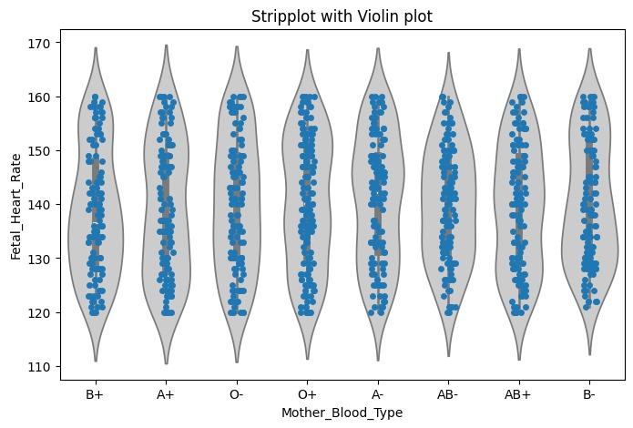The line plot examines the relationship between weight and gestational age. The x-axis represents the weight of the mother, while the y-axis shows the gestational age. The continuous line connecting data points helps identify trends and patterns, revealing how weight changes correlate with gestational age. This visualization is crucial for understanding the progression 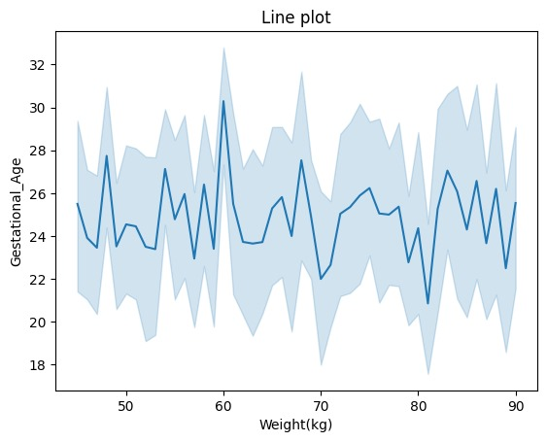of pregnancy in relation to maternal weight.

* Count Plot - Baby Gender and Delivery Type

This count plot compares the number of births by baby gender and delivery type. Using a color palette to differentiate between delivery types, the plot shows the distribution of genders across various delivery methods. This visualization helps in analyzing the frequency of different delivery types for male and female babies, offering insights into delivery trends.

* Count Plot - Mother Blood Type and Anomaly

The count plot displays the distribution of maternal blood types and their association with anomalies. Different colours represent the presence or absence of anomalies, revealing how frequently each blood type is associated with anomalies. This plot is instrumental in understanding the correlation between blood types and the occurrence of anomalies.

* Bar Plot

The bar plot examines the relationship between gestational age and the number of missed checkups, with a distinction made based on maternal mental health status. Each bar represents the number of missed checkups for different gestational ages, categorized by mental health status. This visualization highlights how missed checkups correlate with gestational age and mental health, emphasizing areas for potential intervention.

* Displot

The displot visualizes the distribution of maternal ages, with a histogram showing frequency and a KDE curve illustrating the density of ages. This visualization provides a clear view of the age distribution within the dataset, helping to identify common age ranges and overall trends in maternal age.

* Strip plot with Violin Plot

This combined plot uses a violin plot to show the distribution of foetal heart rates across different maternal blood types, while the stripplot overlays individual data points with jitter to show distribution density. The violin plot provides a summary of the distribution's shape, while the stripplot reveals individual variations. This combination helps in understanding both the overall distribution and specific data points for foetal heart rates by blood type.

* **Visualization: Post-Quarantine Mental Health**
* Line Plot of Education versus Age by Economic Income:

The first visualization is a line plot that examines the relationship between education level and age, with different lines representing varying economic income levels. The x-axis represents different education levels, while the y-axis shows the age of individuals. Different colours or lines indicate different economic income brackets. This plot helps in understanding how age varies with education levels across different economic groups, revealing any trends or patterns in how education and age interact with economic status.

* Histogram of Anxiety State:

The second visualization is a histogram that displays the distribution of anxiety states among individuals. The x-axis represents levels of anxiety, and the y-axis shows the frequency of individuals within each anxiety level. The histogram includes a kernel density estimate (KDE) curve, which provides a smoothed representation of the distribution. This plot helps in visualizing the overall distribution of anxiety states, identifying common anxiety levels, and detecting any peaks or patterns in the data.

* 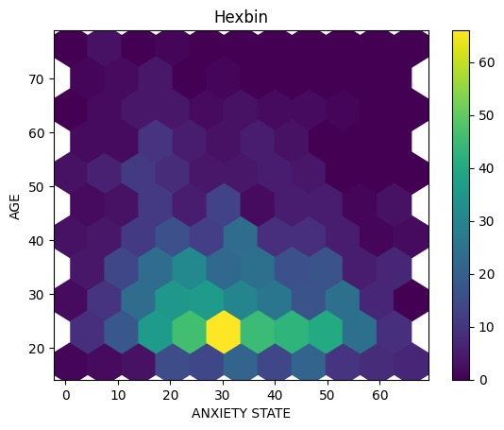Hexbin Plot of Anxiety State versus Age:

The fourth visualization is a hexbin plot that represents the relationship between anxiety state and age using hexagonal bins. The x-axis represents the anxiety state, and the y-axis represents age. The colour intensity in the hexagonal bins indicates the density of data points in each bin. This plot provides a clear view of the relationship between anxiety levels and age, showing how frequently certain combinations of anxiety state and age occur in the dataset.

* Bar Plot of Anxiety Trait by Region and Economic Income:

The fifth visualization is a bar plot that compares anxiety trait levels across different regions, with bars coloured based on economic income brackets. The x-axis represents regions, and the y-axis shows the average anxiety trait level. This plot helps in understanding regional differences in anxiety traits and how these differences are influenced by economic income. The rotation of the x-axis labels ensures that region names are easily readable.

* Scatter Plot of Depression by Region and Economic Income:

The sixth visualization is a scatter plot that shows the relationship between depression levels and regions, with points coloured by economic income. The x-axis represents regions, and the y-axis shows depression levels. This plot allows for an examination of how depression levels vary by region and whether economic income has any impact on these levels. It helps in identifying any patterns or correlations between depression, regions, and economic income.

* 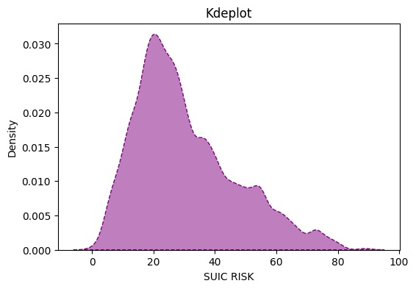Kernel Density Estimate (KDE) Plot of Suicide Risk:

The third visualization is a KDE plot that illustrates the distribution of suicide risk. The x-axis shows the suicide risk levels, while the y-axis represents the density of observations. The KDE curve, with a specified bandwidth adjustment and shaded area, provides a smooth estimate of the distribution. This plot helps in understanding how suicide risk is distributed across the dataset, highlighting areas with higher concentrations of risk and providing insights into the overall risk distribution.

* Count Plot of Education and Mental Disorder History:

The seventh visualization is a count plot that displays the number of individuals with different education levels, categorized by their history of mental disorders. The x-axis represents education levels, while the y-axis shows the count of individuals, with different colours indicating whether they have a history of mental disorders. This plot provides insights into how education levels relate to mental disorder history, revealing any significant patterns or trends.

Each visualization offers a different perspective on the dataset, helping to uncover trends, relationships, and distributions of key variables. Together, these plots provide a comprehensive view of the data, facilitating deeper analysis and interpretation.

* 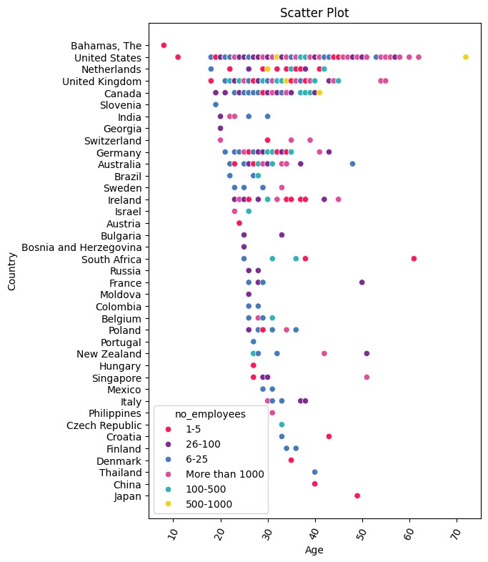**Visualization: Health Trends of Technical Workers**
* Scatter Plot of Age versus Country with Number of Employees

The first visualization is a scatter plot that examines the relationship between age and country, with the colour of the points indicating the number of employees. The x-axis represents age, and the y-axis shows different countries. Each point’s colour, determined by the number of employees, provides insight into how employee numbers are distributed across different age groups and countries. This plot helps identify patterns or clusters in employee distribution relative to age and geographic location, offering a visual representation of how these factors are interconnected.

* Distribution Plot of Age:

The second visualization is a distribution plot (displot) that showcases the age distribution within the dataset. The x-axis represents age, and the y-axis indicates the density of individuals at each age level. The plot includes a kernel density estimate (KDE) curve, which provides a smoothed view of the distribution. This visualization allows for an understanding of how ages are spread across the dataset, highlighting areas where certain age groups are more or less prevalent.

* Kernel Density Estimate (KDE) Plot of Age:

The third visualization is a KDE plot focusing on the distribution of age. The x-axis shows age, while the y-axis represents the density of observations. The plot features a smoothed curve with shaded areas, using a specified bandwidth adjustment to highlight the density distribution. This KDE plot offers a refined view of age distribution, emphasizing peaks and concentration areas, which helps in understanding the underlying distribution patterns of age in the dataset.

* *Line Plot of Number of Employees by Country:*

The fourth visualization is a line plot that tracks the number of employees across different countries. The x-axis represents countries, and the y-axis shows the number of employees. The line connects data points representing the employee count for each country, providing a visual representation of trends and variations in employee numbers globally. This plot is useful for comparing how employee numbers differ by country and identifying any notable trends or patterns in the data.

* Count Plot of Work Interference by Self-Employment Status:

The fifth visualization is a count plot that shows the number of occurrences of different levels of work interference, categorized by self-employment status. The x-axis represents levels of work interference, while the y-axis displays the count of individuals, with different colours indicating whether they are self-employed. This plot helps in understanding how work interference varies between self-employed and non-self-employed individuals, providing insights into potential differences in work-related challenges based on employment status.

* Count Plot of Gender and Care Options:

The sixth visualization is another count plot that examines gender distribution across different care options. The x-axis represents gender, and the y-axis shows the count of individuals for each care option, with different colours representing various care options. This plot provides insights into how care options are distributed among genders, highlighting any significant differences or trends in care preferences based on gender.

* Bar Plot of Age by Gender and Treatment:

The seventh visualization is a bar plot that compares age across different genders and treatments. The x-axis represents gender, while the y-axis shows the average age of individuals, with bars coloured according to treatment types. This plot helps in examining how age varies with gender and treatment types, offering insights into demographic patterns and treatment-related differences in age distribution. The rotation of the x-axis labels ensures better readability of gender categories.

Each of these visualizations provides a distinct perspective on the dataset, highlighting various relationships, distributions, and patterns. Together, they offer a comprehensive view of key variables and their interactions, facilitating deeper analysis and understanding of the data.

* **Visualization: Death patterns of AIDS on various datasets.**
* Bar Plot of Population by Geography:

The second visualization is a bar plot that compares the population across different geographic regions. The x-axis represents different geographical locations, while the y-axis shows the population figures for these regions. Each bar is coloured in a deep hue, providing a clear visual distinction between regions. This plot helps to easily compare population sizes across various geographic areas, revealing any significant differences or patterns in population distribution.

* Line Plot of Population versus Cases:

The third visualization is a line plot that examines the relationship between population and the number of cases. The x-axis represents population size, and the y-axis shows the number of cases. A single line connects data points, coloured to distinguish it from other plots. This visualization helps in understanding how the number of cases correlates with population size, allowing for the identification of trends or patterns where case numbers might increase or decrease with population changes.

* 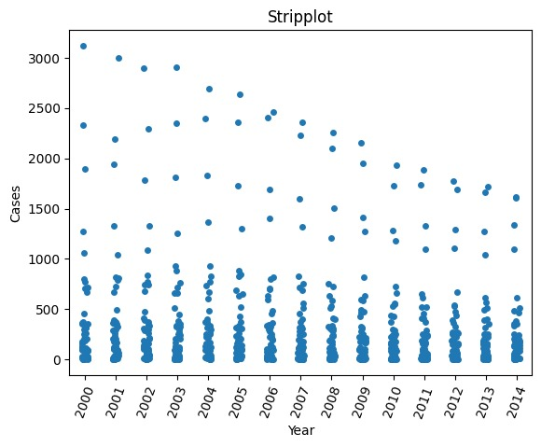Strip Plot of Cases by Year:

The fourth visualization is a strip plot that displays the number of cases over different years. The x-axis represents years, while the y-axis shows the number of cases. In this plot, individual data points are plotted along the y-axis for each year, allowing for a clear view of how case numbers vary from year to year. The rotation of the x-axis labels ensures better readability, especially if there are many years or long-year labels. This plot is useful for visualizing temporal trends and variations in case numbers.

* Histogram of Population:

The final visualization is a histogram that shows the distribution of population figures. The x-axis represents different population ranges, and the y-axis indicates the frequency of these population ranges within the dataset. The histogram includes a kernel density estimate (KDE) curve, providing a smoothed view of the population distribution. This plot helps in understanding how population sizes are distributed across the dataset, revealing any common population ranges and the overall shape of the population distribution.

* 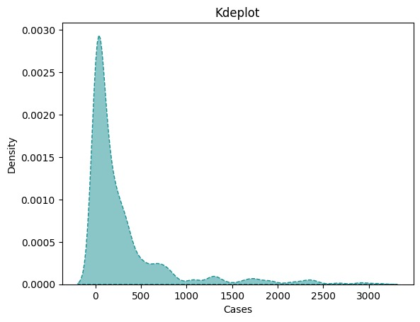Kernel Density Estimate (KDE) Plot of Cases:

The first visualization is a KDE plot that provides a smoothed estimate of the distribution of cases. The x-axis represents the number of cases, and the y-axis shows the density of these cases. The plot includes a shaded area under the curve, which is coloured to emphasize the density distribution and a dashed line that outlines the KDE curve. This visualization helps in understanding the overall distribution and concentration of case numbers, highlighting areas where cases are more or less frequent within the dataset.

Each of these visualizations provides distinct insights into different aspects of the dataset, such as the distribution of cases, population comparisons, temporal trends, and the relationship between population and cases. Together, they offer a comprehensive view of the data, facilitating detailed analysis and interpretation.

**OVERALL CONCLUSION**

**T**he comprehensive analysis of five diverse medical datasets has provided invaluable insights into various aspects of healthcare, mental health, and disease management. Each dataset offered unique perspectives that collectively enhanced our understanding of critical issues and informed targeted interventions.

Hospital Operations and Patient Care: The analysis of the hospital dataset from December 19, 2019, highlighted significant patterns in patient demographics, disease prevalence, and treatment outcomes. The findings underscore the importance of data-driven decision-making to optimize healthcare delivery. By identifying variations in patient demographics, evaluating treatment efficacy, and assessing resource utilization and operational efficiency, the study reveals actionable strategies for improving patient care and streamlining hospital operations.

**P**regnancy Demographics: The study of pregnancy demographics from 1977 to 2005 uncovered critical trends and disparities related to age, socioeconomic status, and health indicators. The insights emphasize the need for age-specific healthcare strategies, addressing socioeconomic barriers, and implementing culturally sensitive practices. Effective management of maternal health conditions and regular prenatal care is crucial for enhancing maternal and neonatal outcomes, paving the way for improved healthcare policies and practices.

**M**ental Health Impacts of COVID-19 Quarantine: The analysis of the mental health impacts of COVID-19 quarantine measures reveals significant correlations between demographic factors, mental health outcomes, and quarantine-related stressors. The study highlights the heightened risk of anxiety and depression among younger individuals and those from lower socioeconomic backgrounds. It also underscores the importance of social support and effective management of pre-existing mental health conditions. The findings advocate for tailored mental health interventions and predictive modeling to better address the mental health challenges posed by quarantine measures.

**M**ental Health in the Tech Industry: The examination of mental health among tech professionals demonstrates that job role, work environment, and access to mental health resources significantly impact mental well-being. The study calls for a proactive approach to mental health support within the tech industry, emphasizing the need for supportive work environments and work-life balance. Continuous monitoring and advanced data analysis techniques are essential for understanding and addressing mental health challenges, ultimately fostering a healthier and more productive work environment.

**A**IDS Mortality Trends: The analysis of AIDS-related mortality from 2000 to 2014 provides a detailed overview of mortality trends across states, revealing that states with robust healthcare infrastructure and higher awareness exhibit lower mortality rates. The findings highlight the necessity of targeted public health interventions, improved healthcare infrastructure, and increased awareness campaigns. Leveraging advanced data processing techniques can further support efforts to reduce AIDS-related deaths and enhance public health strategies.

**I**n conclusion, these analyses collectively underscore the transformative potential of data-driven approaches in enhancing healthcare delivery, improving mental health, and addressing disease management. The insights derived from these datasets offer a solid foundation for developing informed policies, optimizing resource utilization, and implementing targeted interventions. Continued emphasis on data analytics will be crucial in addressing evolving healthcare challenges and ensuring high-quality, efficient, and patient-centered care across various domains.